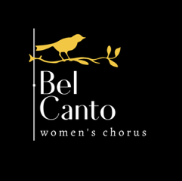
Financial Aid Application
The Bel Canto Women’s Chorus is pleased to be able to provide financial aid in the form of reduced tuition, for those who need it. We don’t want money to be the reason that singers cannot sing with us. We are grateful to our donors who contribute to this scholarship fund. The information provided on this form will not be shared with anyone except the scholarship committee. In return for your need-based reduced tuition, we ask that you:
- Please be honest in describing your financial situation.
- Please consider contributing to the organization by volunteering with Bel Canto.
- Please keep the amount of your personal financial aid award confidential.
- Please consider approaching any businesses or individuals you know who might be willing to make a tax-deductible contribution in the form of a scholarship to Inspire Choral Arts.

TO APPLY FOR FINANCIAL AID, send an email to belcantosings@gmail.com that answers these two questions:
1. Please provide your name, and describe the reason you are applying for financial aid:
2. Please indicate which level of tuition reduction is necessary in order for you to participate (please be honest):
_______25% Less Tuition/Fees
_______50% Less Tuition/Fees
_______75% Less Tuition/Fees
_______100% Tuition/Fees waiver
After sending the email:
A member of the scholarship committee should have a response to you within about one week, often much sooner. If you don’t hear back within that time, please let us know!

